# Project Title: <Indian Hotel Industry>

# NAME: <ASHUTOSH SHAW>

# EMAIL: <ashu.shaw09@gmail.com>

# COLLEGE: <DTU>

**OUTPUTS**

summary(hotel.df)

CityName Population CityRank IsMetroCity IsTouristDestination IsWeekend IsNewYearEve Date

Delhi :2048 Min. : 8096 Min. : 0.00 Min. :0.0000 Min. :0.0000 Min. :0.0000 Min. :0.0000 Dec 21 2016:1611

Jaipur : 768 1st Qu.: 744983 1st Qu.: 2.00 1st Qu.:0.0000 1st Qu.:0.0000 1st Qu.:0.0000 1st Qu.:0.0000 Dec 24 2016:1611

Mumbai : 712 Median : 3046163 Median : 9.00 Median :0.0000 Median :1.0000 Median :1.0000 Median :0.0000 Dec 25 2016:1611

Bangalore: 656 Mean : 4416837 Mean :14.83 Mean :0.2842 Mean :0.6972 Mean :0.6228 Mean :0.1244 Dec 28 2016:1611

Goa : 624 3rd Qu.: 8443675 3rd Qu.:24.00 3rd Qu.:1.0000 3rd Qu.:1.0000 3rd Qu.:1.0000 3rd Qu.:0.0000 Dec 31 2016:1611

Kochi : 608 Max. :12442373 Max. :44.00 Max. :1.0000 Max. :1.0000 Max. :1.0000 Max. :1.0000 Dec 18 2016:1608

(Other) :7816 (Other) :3569

HotelName RoomRent StarRating Airport

Vivanta by Taj : 32 Min. : 299 Min. :0.000 Min. : 0.20

Goldfinch Hotel : 24 1st Qu.: 2436 1st Qu.:3.000 1st Qu.: 8.40

OYO Rooms : 24 Median : 4000 Median :3.000 Median : 15.00

The Gordon House Hotel: 24 Mean : 5474 Mean :3.459 Mean : 21.16

Apnayt Villa : 16 3rd Qu.: 6299 3rd Qu.:4.000 3rd Qu.: 24.00

Bentleys Hotel Colaba : 16 Max. :322500 Max. :5.000 Max. :124.00

(Other) :13096

HotelAddress HotelPincode HotelDescription FreeWifi

The Mall, Shimla : 32 Min. : 100025 3 : 120 Min. :0.0000

#2-91/14/8, White Fields, Kondapur, Hitech City, Hyderabad, 500084 India: 16 1st Qu.: 221001 Abc : 112 1st Qu.:1.0000

121, City Terrace, Walchand Hirachand Marg, Mumbai, Maharashtra : 16 Median : 395003 3-star hotel: 104 Median :1.0000

14-4507/9, Balmatta Road, Near Jyothi Circle, Hampankatta : 16 Mean : 397430 3.5 : 88 Mean :0.9259

144/7, Rajiv Gandi Salai (OMR), Kottivakkam, Chennai, Tamil Nadu : 16 3rd Qu.: 570001 4 : 72 3rd Qu.:1.0000

17, Oliver Road, Colaba, Mumbai, Maharashtra : 16 Max. :7000157 (Other) :12728 Max. :1.0000

(Other) :13120 NA's : 8

FreeBreakfast HotelCapacity HasSwimmingPool

Min. :0.0000 Min. : 0.00 Min. :0.0000

1st Qu.:0.0000 1st Qu.: 16.00 1st Qu.:0.0000

Median :1.0000 Median : 34.00 Median :0.0000

Mean :0.6491 Mean : 62.51 Mean :0.3558

3rd Qu.:1.0000 3rd Qu.: 75.00 3rd Qu.:1.0000

Max. :1.0000 Max. :600.00 Max. :1.0000

cor.test(hotel.df$RoomRent,hotel.df$IsNewYearEve)

Pearson's product-moment correlation

data: hotel.df$RoomRent and hotel.df$IsNewYearEve

t = 4.4306, df = 13230, p-value = 9.472e-06

alternative hypothesis: true correlation is not equal to 0

95 percent confidence interval:

0.02146637 0.05549377

sample estimates:

cor

0.03849123

cor.test(hotel.df$RoomRent,hotel.df$IsMetroCity)

Pearson's product-moment correlation

data: hotel.df$RoomRent and hotel.df$IsMetroCity

t = -7.7053, df = 13230, p-value = 1.399e-14

alternative hypothesis: true correlation is not equal to 0

95 percent confidence interval:

-0.08378329 -0.04985761

sample estimates:

cor

-0.06683977

cor.test(hotel.df$RoomRent,hotel.df$HasSwimmingPool)

Pearson's product-moment correlation

data: hotel.df$RoomRent and hotel.df$HasSwimmingPool

t = 37.726, df = 13230, p-value < 2.2e-16

alternative hypothesis: true correlation is not equal to 0

95 percent confidence interval:

0.2961917 0.3269604

sample estimates:

cor

0.3116577

cor.test(hotel.df$RoomRent,hotel.df$StarRating)

Pearson's product-moment correlation

data: hotel.df$RoomRent and hotel.df$StarRating

t = 45.719, df = 13230, p-value < 2.2e-16

alternative hypothesis: true correlation is not equal to 0

95 percent confidence interval:

0.3545660 0.3839956

sample estimates:

cor

0.3693734

cor.test(hotel.df$RoomRent,hotel.df$HotelCapacity)

Pearson's product-moment correlation

data: hotel.df$RoomRent and hotel.df$HotelCapacity

t = 18.389, df = 13230, p-value < 2.2e-16

alternative hypothesis: true correlation is not equal to 0

95 percent confidence interval:

0.1412142 0.1744430

sample estimates:

cor

0.1578733

my_data <- hotel1.df[, c(3:7,10:12,16:19)]

> res<-cor(my_data)

> round(res,2)

CityRank IsMetroCity IsTouristDestination IsWeekend IsNewYearEve RoomRent StarRating Airport FreeWifi FreeBreakfast HotelCapacity

CityRank 1.00 -0.56 0.28 -0.01 0.00 0.09 -0.13 0.51 -0.12 -0.01 -0.26

IsMetroCity -0.56 1.00 0.18 0.00 0.00 -0.07 0.08 -0.21 0.09 0.05 0.19

IsTouristDestination 0.28 0.18 1.00 -0.02 0.00 0.12 -0.04 0.19 -0.06 -0.07 -0.09

IsWeekend -0.01 0.00 -0.02 1.00 0.29 0.00 0.01 0.00 0.00 -0.01 0.01

IsNewYearEve 0.00 0.00 0.00 0.29 1.00 0.04 0.00 0.00 0.00 0.00 0.00

RoomRent 0.09 -0.07 0.12 0.00 0.04 1.00 0.37 0.05 0.00 -0.01 0.16

StarRating -0.13 0.08 -0.04 0.01 0.00 0.37 1.00 -0.06 0.01 -0.03 0.64

Airport 0.51 -0.21 0.19 0.00 0.00 0.05 -0.06 1.00 -0.10 0.02 -0.12

FreeWifi -0.12 0.09 -0.06 0.00 0.00 0.00 0.01 -0.10 1.00 0.16 -0.01

FreeBreakfast -0.01 0.05 -0.07 -0.01 0.00 -0.01 -0.03 0.02 0.16 1.00 -0.09

HotelCapacity -0.26 0.19 -0.09 0.01 0.00 0.16 0.64 -0.12 -0.01 -0.09 1.00

HasSwimmingPool -0.10 0.02 0.04 0.00 0.00 0.31 0.62 -0.14 -0.03 -0.06 0.51

HasSwimmingPool

CityRank -0.10

IsMetroCity 0.02

IsTouristDestination 0.04

IsWeekend 0.00

IsNewYearEve 0.00

RoomRent 0.31

StarRating 0.62

Airport -0.14

FreeWifi -0.03

FreeBreakfast -0.06

HotelCapacity 0.51

HasSwimmingPool 1.00

mytable<-xtabs(~RoomRent+HasSwimmingPool , data =hotel1.df)

> mytable

HasSwimmingPool

RoomRent 0 1

299 2 0

324 1 0

349 6 0

491 1 0

499 1 0

500 6 0

504 3 0

540 5 0

560 4 0

605 2 0

613 2 0

623 1 0

642 3 0

650 1 0

655 3 0

679 0 6

698 2 0

727 4 0

766 6 0

780 4 0

796 1 0

798 7 0

799 12 0

801 6 0

824 3 0

834 2 0

844 8 0

850 11 0

851 3 0

852 2 0

874 4 0

877 2 0

880 1 0

896 1 0

897 2 0

909 8 0

915 5 0

921 3 0

922 2 0

931 3 0

937 7 0

950 4 0

953 4 0

968 5 0

971 4 0

984 1 0

990 1 0

995 7 0

999 11 0

1000 5 4

1001 1 0

1013 10 0

1021 4 0

1022 2 0

1042 12 0

1045 0 2

1050 1 0

1059 4 0

1061 7 0

1064 2 0

1065 1 0

1067 3 0

1073 1 0

1080 2 7

1083 2 0

1087 7 0

1100 6 0

1102 1 0

1106 6 0

1118 3 0

1120 2 0

1121 1 0

1130 1 0

1145 1 0

1150 6 0

1158 5 0

1172 3 0

1176 2 0

1177 3 0

1184 2 0

1188 2 0

1189 5 0

1191 5 0

1199 3 0

1200 21 2

1206 1 0

1211 2 0

1215 4 0

1217 2 0

1221 2 0

1234 3 0

1239 1 0

1244 8 0

1245 2 0

1248 0 3

1250 2 0

1251 3 0

1252 2 0

1256 1 0

1261 2 0

1265 6 0

1274 7 0

1276 4 0

1277 14 0

1280 1 0

1281 1 0

1286 4 0

1289 11 0

1291 1 0

1294 2 0

1299 6 0

1300 18 0

1302 7 0

1303 6 0

1307 3 0

1313 1 0

1318 5 0

1319 13 0

1323 1 0

1324 5 0

1334 11 0

1336 2 0

1340 0 5

1341 2 0

1348 4 0

1349 2 0

1350 12 0

1351 3 0

1359 9 0

1360 1 0

1361 7 0

1362 32 0

1376 2 0

1377 4 0

1380 6 0

1381 1 0

1391 2 0

1396 1 0

1399 11 0

1400 6 0

1402 1 0

1404 13 0

1410 9 0

1413 3 0

1416 1 0

1418 4 0

1419 2 0

1422 4 0

1429 0 5

1430 0 1

1432 3 0

1434 1 0

1438 4 0

1440 4 0

1447 13 0

1448 2 0

1450 2 0

1459 2 0

1460 0 1

1461 1 0

1463 3 0

1468 9 0

1474 1 0

1476 8 0

1477 3 0

1482 1 0

1485 7 0

1489 6 0

1490 23 5

1491 5 0

1492 1 0

1493 6 0

1495 6 0

1498 4 0

1499 5 0

1500 31 1

1501 7 0

1507 1 0

1511 3 0

1513 0 2

1519 3 0

1520 6 0

1525 2 0

1529 7 0

1530 3 0

1532 31 0

1534 1 0

1535 1 0

1539 6 0

1543 1 0

1547 0 1

1549 1 0

1550 3 0

1551 2 0

1552 2 0

1558 3 0

1559 2 0

1560 1 0

1568 4 0

1571 4 0

1575 30 0

1579 10 0

1581 6 0

1582 2 0

1588 13 0

1589 1 0

1596 0 2

1599 12 0

1600 32 0

1601 9 0

1605 1 0

1610 7 0

1611 3 0

1614 2 0

1615 1 0

1617 33 0

1619 12 0

1620 4 0

1625 5 0

1627 1 0

1628 6 0

1630 2 0

1634 3 0

1640 3 0

1641 6 0

1642 5 0

1645 6 0

1647 2 0

1649 3 0

1650 22 0

1651 0 1

1653 1 0

1654 0 1

1656 6 0

1657 5 0

1660 40 0

1665 2 0

1666 5 0

1667 2 0

1672 2 0

1675 2 0

1678 5 0

1680 5 0

1681 3 0

1686 3 0

1688 0 1

1689 3 0

1699 9 0

1700 33 0

1702 45 3

1703 5 0

1708 0 1

1713 3 0

1715 1 0

1717 3 0

1719 7 4

1720 2 0

1724 5 0

1725 1 0

1728 5 0

1731 1 0

1733 5 0

1737 2 0

1739 12 0

1741 7 0

1745 39 0

1746 7 0

1748 3 0

1749 2 0

1750 9 0

1751 4 0

1752 1 0

1755 1 0

1756 7 0

1759 0 2

1760 2 6

1761 0 1

1764 11 0

1768 1 0

1771 3 0

1775 6 0

1778 5 0

1782 7 0

1785 6 0

1788 27 0

1798 6 0

1799 14 0

1800 32 8

1806 1 0

1809 1 0

1811 1 0

1814 1 0

1815 1 0

1818 7 0

1819 1 0

1824 7 0

1825 0 1

1826 5 0

1828 7 0

1829 2 0

1830 41 0

1833 4 0

1834 0 2

1837 1 0

1839 0 6

1840 4 0

1842 1 0

1847 1 0

1849 4 0

1850 6 0

1851 4 0

1852 5 0

1859 2 0

1862 7 3

1863 7 0

1866 1 0

1868 4 0

1870 0 1

1872 2 0

1873 4 5

1875 2 0

1881 9 0

1884 2 0

1885 6 0

1887 6 0

1889 6 0

1890 4 0

1891 5 0

1893 6 0

1894 6 0

1899 17 14

1900 14 6

1904 5 0

1905 7 0

1912 1 0

1913 6 0

1914 0 1

1915 31 0

1916 4 0

1919 1 0

1920 3 0

1925 2 0

1926 3 0

1928 8 0

1936 1 0

1938 2 0

1940 6 0

1941 2 0

1944 1 0

1947 1 0

1948 2 0

1949 3 0

1950 22 0

1955 7 0

1956 3 0

1958 28 0

1959 4 0

1960 14 0

1961 2 0

1962 2 0

1968 1 0

1971 1 0

1973 2 0

1979 14 0

1980 12 0

1982 2 0

1984 2 0

1985 2 0

1987 1 4

1990 5 0

1996 9 0

1998 6 0

1999 19 4

2000 59 21

2001 17 1

2002 1 0

2004 5 0

2008 1 0

2011 3 0

2015 3 0

2016 6 0

2018 1 0

2019 2 0

2022 7 0

2025 6 0

2027 1 0

2029 1 0

2032 2 0

2033 1 0

2036 4 0

2039 2 1

2043 22 0

2049 4 0

2050 5 0

2051 1 0

2059 2 0

2060 4 0

2062 2 0

2065 1 0

2068 1 0

2069 8 0

2070 4 7

2073 2 0

2075 6 0

2076 4 0

2077 2 0

2079 6 0

2080 3 0

2081 1 0

2082 4 0

2083 6 1

2084 3 0

2086 31 0

2087 0 2

2092 2 0

2093 3 0

2097 2 0

2099 4 0

2100 19 0

2101 2 0

2104 1 0

2106 5 0

2110 7 0

2111 4 0

2124 8 0

2125 2 0

2126 3 0

2127 2 0

2128 22 1

2130 3 0

2131 2 0

2137 5 0

2139 2 0

2142 0 6

2148 2 0

2149 4 0

2150 5 10

2153 3 0

2159 3 0

2160 13 0

2161 3 0

2163 2 0

2166 7 0

2167 0 1

2168 7 0

2170 3 0

2171 16 0

2174 1 0

2175 0 3

2179 3 0

2180 2 0

2181 9 0

2183 9 0

2191 3 0

2193 5 0

2198 1 0

2199 26 3

2200 51 2

2201 7 0

2202 0 6

2210 3 0

2213 46 1

2215 1 0

2222 3 0

2223 0 1

2224 10 0

2227 2 0

2235 3 0

2236 2 0

2238 2 0

2240 1 0

2249 10 0

2250 28 5

2252 10 0

2254 2 0

2256 45 0

2261 1 0

2268 1 0

2269 6 0

2275 4 2

2280 7 0

2288 4 0

2289 1 0

2290 3 0

2291 1 0

2293 10 0

2294 4 0

2295 7 0

2299 35 0

2300 21 1

2310 1 0

2313 5 0

2314 4 0

2315 4 0

2316 3 0

2317 3 0

2318 5 0

2319 2 0

2331 6 0

2333 1 2

bwplot(hotel1.df$RoomRent~hotel1.df$StarRating)

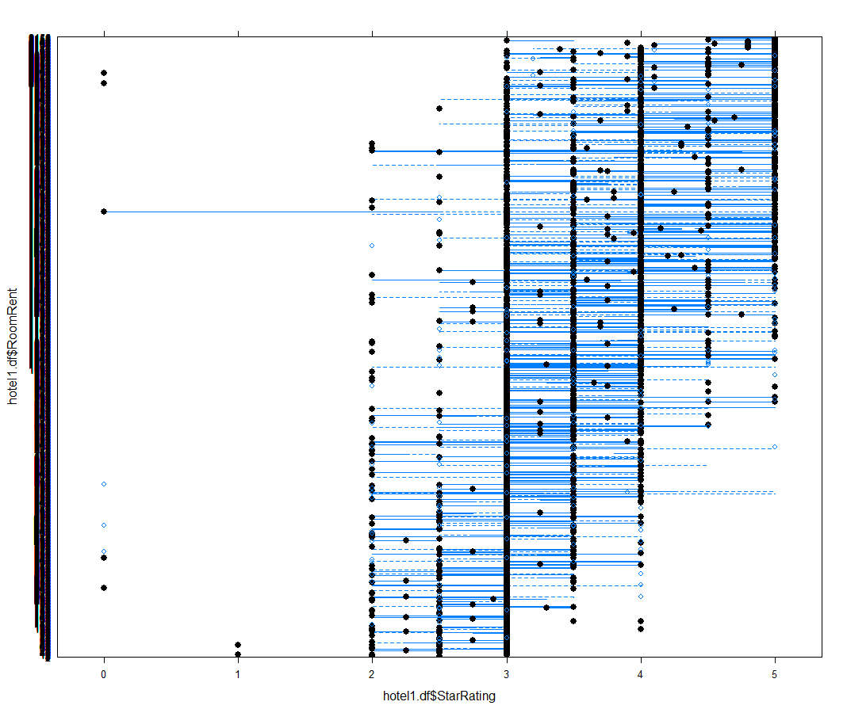

scatterplot(hotel1.df$RoomRent~hotel1.df$HasSwimmingPool)

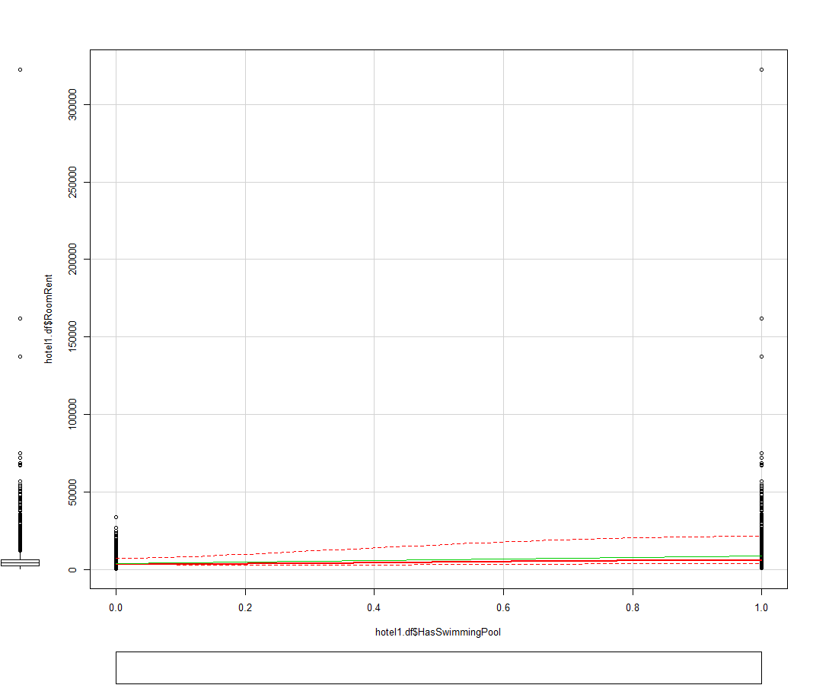

scatterplot(hotel1.df$RoomRent~hotel1.df$StarRating)

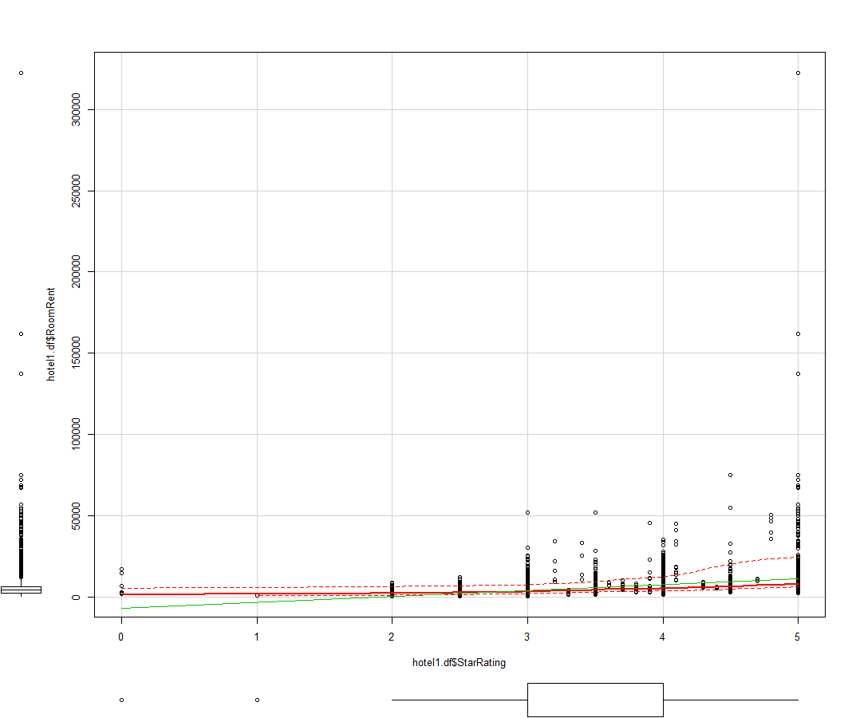

scatterplot(hotel1.df$RoomRent~hotel1.df$HotelCapacity)

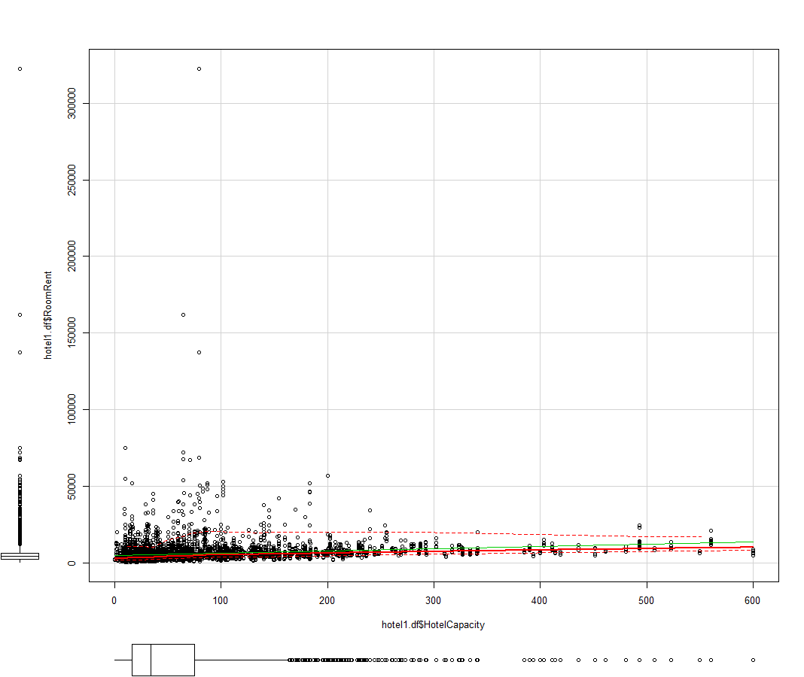

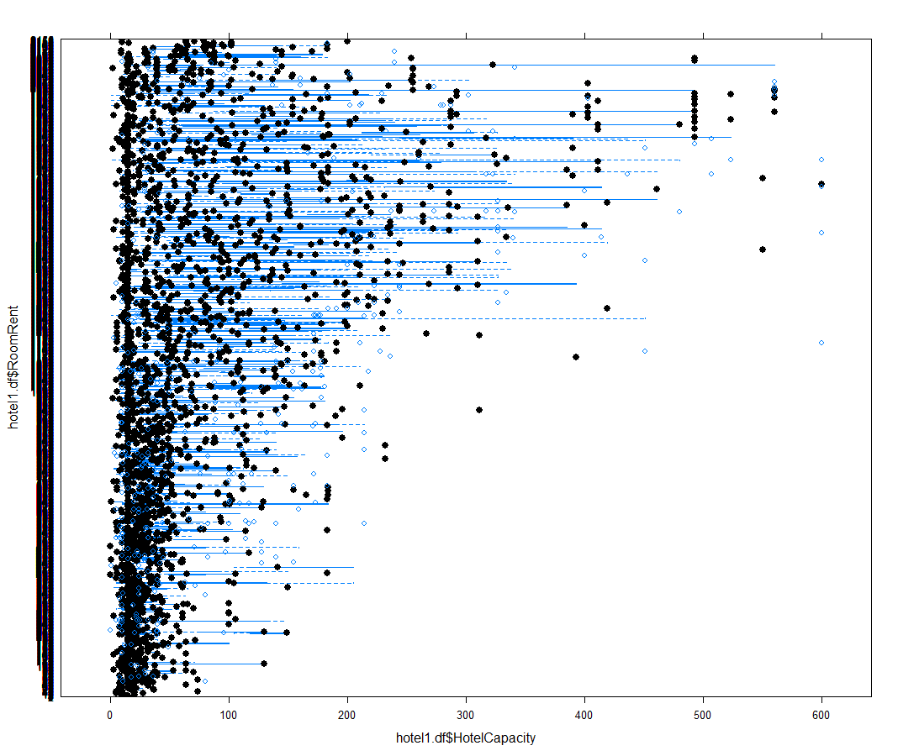

scatterplotMatrix(

+ hotel1.df[

+ ,c("RoomRent","HasSwimmingPool","StarRating","HotelCapacity")],

+ spread=TRUE, smoother.args=list(lty=2),

+ main="Scatter Plot Matrix")

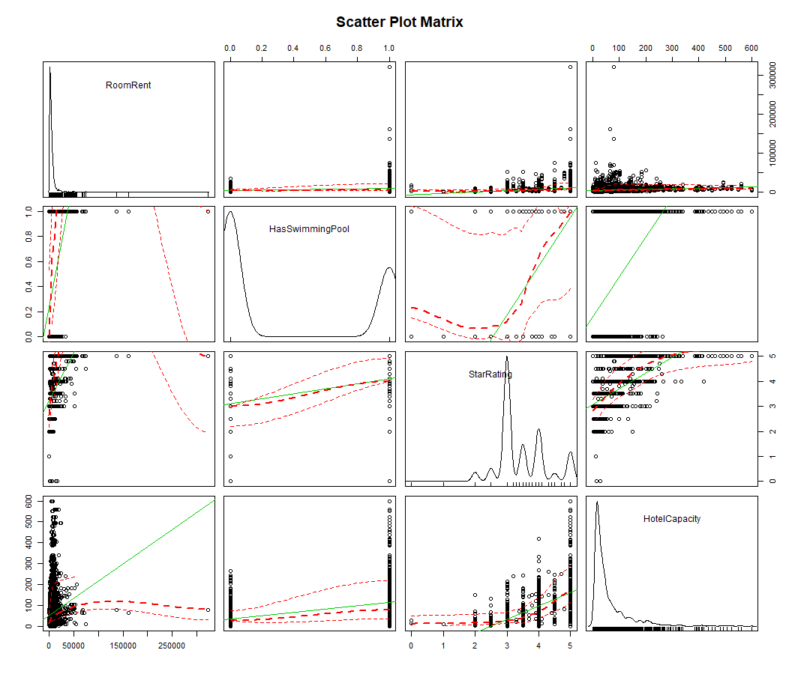

library(corrgram)

> corrgram( hotel1.df[,hotelpricing2], order=TRUE,

+ main="Hotel Pricing in India",

+ lower.panel=panel.pts, upper.panel=panel.pie,

+ diag.panel=panel.minmax, text.panel=panel.txt)

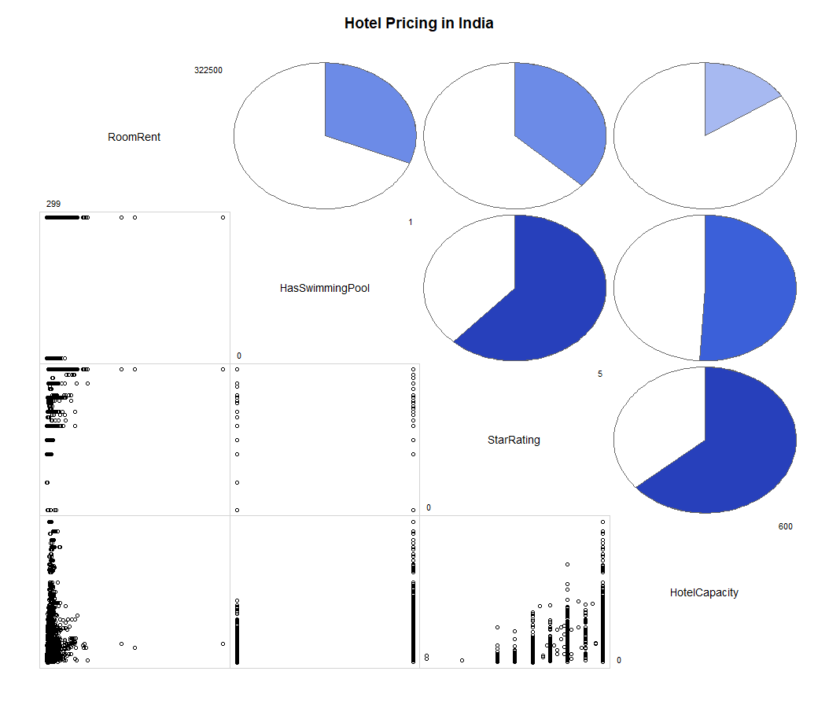

my_data1 <- hotel1.df[, c(10,11 , 18 ,19)]

> res<-cor(my_data1)

> round(res,2)

RoomRent StarRating HotelCapacity HasSwimmingPool

RoomRent 1.00 0.37 0.16 0.31

StarRating 0.37 1.00 0.64 0.62

HotelCapacity 0.16 0.64 1.00 0.51

HasSwimmingPool 0.31 0.62 0.51 1.00

> reg1<-cbind(RoomRent,HasSwimmingPool,HotelCapacity,StarRating) #Internal factors

> reg2<-cbind(RoomRent,IsNewYearEve,IsMetroCity,IsTouristDestination,CityRank) #External Factors

> t.test(reg1,reg2)

Welch Two Sample t-test

data: reg1 and reg2

t = 11.777, df = 107870, p-value < 2.2e-16

alternative hypothesis: true difference in means is not equal to 0

95 percent confidence interval:

239.3149 334.8717

sample estimates:

mean of x mean of y

1385.080 1097.986

> t.test(tdhotel$RoomRent,tdhotel$IsMetroCity)

Welch Two Sample t-test

boxplot(hotel1.df$RoomRent,hotel1.df$IsTouristDestination)

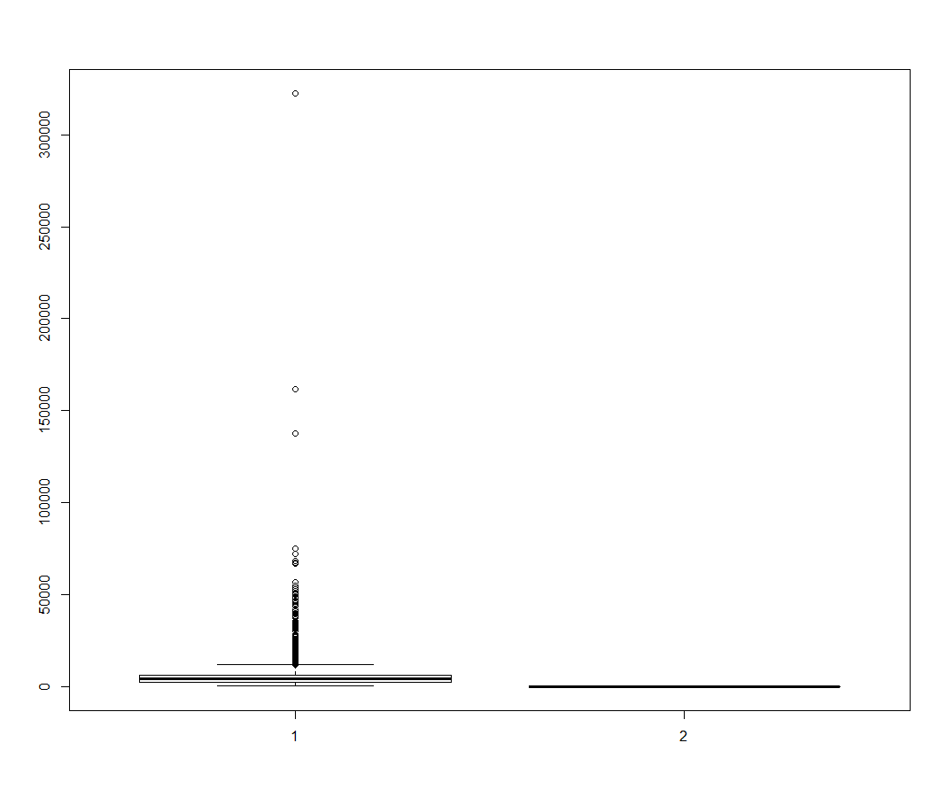

t.test(hotel1.df$RoomRent[hotel1.df$IsTouristDestination==1],hotel1.df$RoomRent[hotel1.df$IsTouristDestination==0])

Welch Two Sample t-test

data: hotel1.df$RoomRent[hotel1.df$IsTouristDestination == 1] and hotel1.df$RoomRent[hotel1.df$IsTouristDestination == 0]

t = 19.466, df = 12876, p-value < 2.2e-16

alternative hypothesis: true difference in means is not equal to 0

95 percent confidence interval:

1760.783 2155.102

sample estimates:

mean of x mean of y

6068.946 4111.003

> Model1<-RoomRent ~ StarRating + HotelCapacity +HasSwimmingPool

> fit1 <- lm(Model1, data = project)

> summary(fit1)

Call:

lm(formula = Model1, data = project)

Residuals:

Min 1Q Median 3Q Max

-10804 -2295 -946 1002 310110

Coefficients:

Estimate Std. Error t value Pr(>|t|)

(Intercept) -6896.154 340.549 -20.25 <2e-16 ***

StarRating 3597.322 111.670 32.21 <2e-16 ***

HotelCapacity -15.558 1.006 -15.47 <2e-16 ***

HasSwimmingPool 2528.885 157.894 16.02 <2e-16 ***

---

Signif. codes: 0 ‘***’ 0.001 ‘**’ 0.01 ‘*’ 0.05 ‘.’ 0.1 ‘ ’ 1

Residual standard error: 6710 on 13228 degrees of freedom

Multiple R-squared: 0.1628, Adjusted R-squared: 0.1626

F-statistic: 857.5 on 3 and 13228 DF, p-value: < 2.2e-16

|  |
| --- |
| > fit1$coefficients  (Intercept) StarRating HotelCapacity HasSwimmingPool  -6896.15387 3597.32177 -15.55769 2528.88529  > confint(fit1)  2.5 % 97.5 %  (Intercept) -7563.67956 -6228.62818  StarRating 3378.43262 3816.21092  HotelCapacity -17.52942 -13.58596  HasSwimmingPool 2219.38993 2838.38064 |
| > fit1$coefficients  (Intercept) StarRating HotelCapacity HasSwimmingPool  -6896.15387 3597.32177 -15.55769 2528.88529  > confint(fit1)  2.5 % 97.5 %  (Intercept) -7563.67956 -6228.62818  StarRating 3378.43262 3816.21092  HotelCapacity -17.52942 -13.58596  HasSwimmingPool 2219.38993 2838.38064   |  | | --- | | > Model2<-RoomRent~IsNewYearEve+IsMetroCity+IsTouristDestination+CityRank  > fit2 <- lm(Model2, data = hotel1.df)  > summary(fit2)  Call:  lm(formula = Model2, data = hotel1.df)  Residuals:  Min 1Q Median 3Q Max  -6945 -2901 -1303 1043 316094  Coefficients:  Estimate Std. Error t value Pr(>|t|)  (Intercept) 4201.480 142.323 29.521 < 2e-16 ***  IsNewYearEve 863.418 190.799 4.525 6.08e-06 ***  IsMetroCity -1416.510 186.609 -7.591 3.39e-14 ***  IsTouristDestination 2171.934 157.543 13.786 < 2e-16 ***  CityRank 3.600 6.388 0.564 0.573  ---  Signif. codes: 0 ‘***’ 0.001 ‘**’ 0.01 ‘*’ 0.05 ‘.’ 0.1 ‘ ’ 1  Residual standard error: 7243 on 13227 degrees of freedom  Multiple R-squared: 0.02461, Adjusted R-squared: 0.02432  F-statistic: 83.45 on 4 and 13227 DF, p-value: < 2.2e-16  > fit2$coefficients  (Intercept) IsNewYearEve IsMetroCity  4201.479658 863.417683 -1416.510427  IsTouristDestination CityRank  2171.933759 3.600397  > confint(fit2)  2.5 % 97.5 %  (Intercept) 3922.506685 4480.45263  IsNewYearEve 489.425251 1237.41012  IsMetroCity -1782.291410 -1050.72944  IsTouristDestination 1863.126748 2480.74077  CityRank -8.921011 16.12181  > AIC(fit1)  [1] 270742.2  > AIC(fit2)  [1] 272765.7 | |

fit3<-lm(RoomRent~IsTouristDestination , data =hotel1.df)

> summary(fit3)

Call:

lm(formula = RoomRent ~ IsTouristDestination, data = hotel1.df)

Residuals:

Min 1Q Median 3Q Max

-5770 -2961 -1281 931 316431

Coefficients:

Estimate Std. Error t value Pr(>|t|)

(Intercept) 4111.0 115.0 35.75 <2e-16 ***

IsTouristDestination 1957.9 137.8 14.21 <2e-16 ***

---

Signif. codes: 0 ‘***’ 0.001 ‘**’ 0.01 ‘*’ 0.05 ‘.’ 0.1 ‘ ’ 1

Residual standard error: 7280 on 13222 degrees of freedom

Multiple R-squared: 0.01505, Adjusted R-squared: 0.01497

F-statistic: 202 on 1 and 13222 DF, p-value: < 2.2e-16

coefficients(fit3)

(Intercept) IsTouristDestination

4111.003 1957.943

boxplot(hotel1.df$RoomRent,hotel1.df$IsMetroCity,horizontal = TRUE)

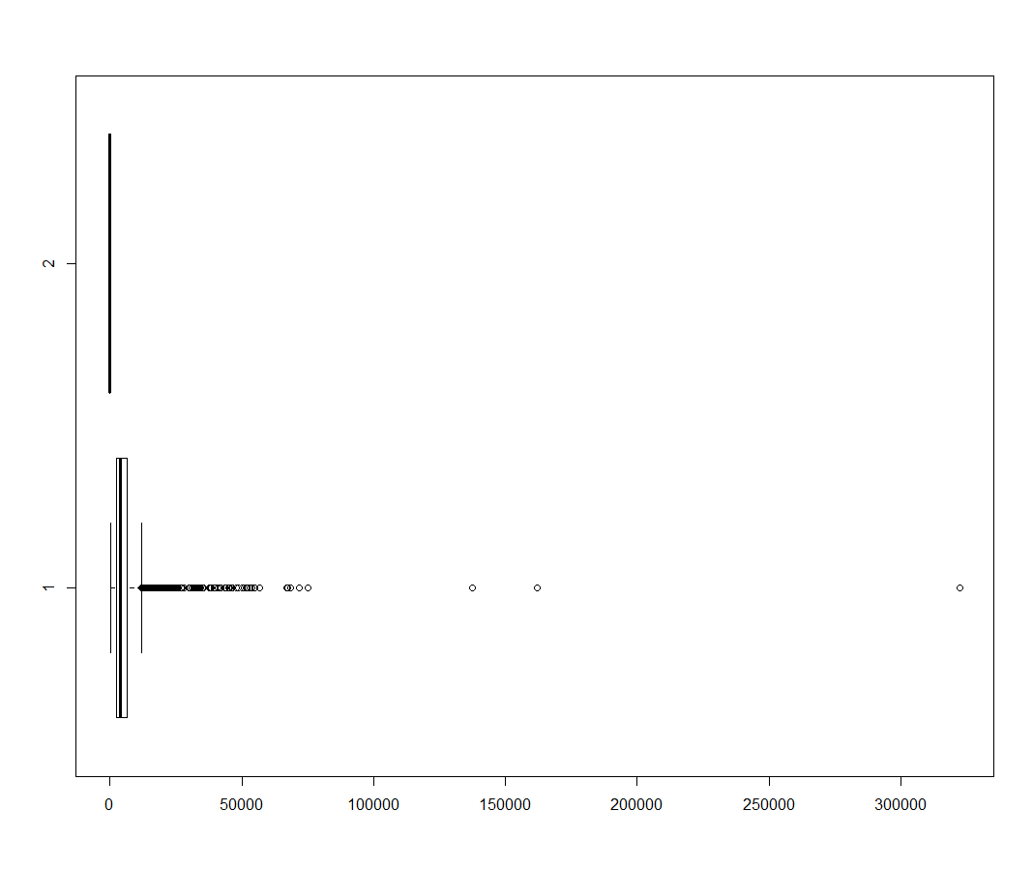

t.test(hotel1.df$RoomRent[hotel1.df$IsMetroCity==1],hotel1.df$RoomRent[hotel1.df$IsMetroCity==0])

Welch Two Sample t-test

data: hotel1.df$RoomRent[hotel1.df$IsMetroCity == 1] and hotel1.df$RoomRent[hotel1.df$IsMetroCity == 0]

t = -10.674, df = 13218, p-value < 2.2e-16

alternative hypothesis: true difference in means is not equal to 0

95 percent confidence interval:

-1281.2485 -883.6805

sample estimates:

mean of x mean of y

4700.329 5782.794

fit4<-lm(RoomRent~IsMetroCity , data =hotel1.df)

> summary(fit4)

Call:

lm(formula = RoomRent ~ IsMetroCity, data = hotel1.df)

Residuals:

Min 1Q Median 3Q Max

-5484 -2988 -1522 922 316717

Coefficients:

Estimate Std. Error t value Pr(>|t|)

(Intercept) 5782.8 75.2 76.896 < 2e-16 ***

IsMetroCity -1082.5 141.2 -7.667 1.88e-14 ***

---

Signif. codes: 0 ‘***’ 0.001 ‘**’ 0.01 ‘*’ 0.05 ‘.’ 0.1 ‘ ’ 1

Residual standard error: 7319 on 13222 degrees of freedom

Multiple R-squared: 0.004426, Adjusted R-squared: 0.004351

F-statistic: 58.78 on 1 and 13222 DF, p-value: 1.882e-14

|  |
| --- |
|  |
|  |

Delhi <- hotel1.df[ which(hotel1.df$CityName=="Delhi") , ]

> summary(Delhi)

CityName Population CityRank IsMetroCity IsTouristDestination IsWeekend IsNewYearEve Date

Delhi :2048 Min. :11034555 Min. :1 Min. :1 Min. :1 Min. :0.0000 Min. :0.000 Dec 18 2016:256

Agra : 0 1st Qu.:11034555 1st Qu.:1 1st Qu.:1 1st Qu.:1 1st Qu.:0.0000 1st Qu.:0.000 Dec 21 2016:256

Ahmedabad : 0 Median :11034555 Median :1 Median :1 Median :1 Median :1.0000 Median :0.000 Dec 24 2016:256

Amritsar : 0 Mean :11034555 Mean :1 Mean :1 Mean :1 Mean :0.6274 Mean :0.125 Dec 25 2016:256

Bangalore : 0 3rd Qu.:11034555 3rd Qu.:1 3rd Qu.:1 3rd Qu.:1 3rd Qu.:1.0000 3rd Qu.:0.000 Dec 28 2016:256

Bhubaneswar: 0 Max. :11034555 Max. :1 Max. :1 Max. :1 Max. :1.0000 Max. :1.000 Dec 31 2016:256

(Other) : 0 (Other) :512

HotelName RoomRent StarRating Airport

OYO Rooms : 24 Min. : 798 Min. :2.000 Min. : 1.9

Courtyard by Marriott Gurugram Downtown: 16 1st Qu.: 1998 1st Qu.:3.000 1st Qu.:11.0

Lemon Tree Premier : 16 Median : 3225 Median :3.000 Median :15.0

Mosaic Hotels : 16 Mean : 4319 Mean :3.573 Mean :14.7

Aapno Ghar Resort : 8 3rd Qu.: 5760 3rd Qu.:4.000 3rd Qu.:16.5

Ahuja Residency : 8 Max. :45000 Max. :5.000 Max. :43.0

(Other) :1960

HotelAddress HotelPincode HotelDescription

443,Udyog vihar : 16 Min. :100025 3-star Gurgaon hotel with restaurant : 56

1 Old Judicial Complex, Jharsa Road, Sector-15, Gurgaon, Delhi N.C.R, India : 8 1st Qu.:110024 Gurgaon hotel next to shopping : 56

1&2 Ring Road : 8 Median :110055 3-star hotel with restaurant, near Jantar Mantar: 48

1/1 West Patel Nagar, Opp Metro Pillar 209, New Delhi, Delhi N.C.R, 110008, India: 8 Mean :119194 3-star hotel : 32

1028 Sector 46, Gurgaon : 8 3rd Qu.:122001 3-star hotel in Central Delhi with restaurant : 32

1078-80, Hardhyan Singh Road, Naiwalan, Karol Bagh, New Delhi, Delhi N.C.R : 8 Max. :201309 3-star hotel with restaurant, near Jama Masjid : 32

(Other) :1992 (Other) :1792

FreeWifi FreeBreakfast HotelCapacity HasSwimmingPool

Min. :0.0000 Min. :0.0000 Min. : 5.00 Min. :0.0000

1st Qu.:1.0000 1st Qu.:0.0000 1st Qu.: 20.00 1st Qu.:0.0000

Median :1.0000 Median :1.0000 Median : 36.50 Median :0.0000

Mean :0.9766 Mean :0.6816 Mean : 82.70 Mean :0.3633

3rd Qu.:1.0000 3rd Qu.:1.0000 3rd Qu.: 84.25 3rd Qu.:1.0000

Max. :1.0000 Max. :1.0000 Max. :550.00 Max. :1.0000

> Mumbai <- hotel1.df[ which(hotel1.df$CityName=="Mumbai") , ]

> summary(Mumbai)

CityName Population CityRank IsMetroCity IsTouristDestination IsWeekend IsNewYearEve Date

Mumbai :712 Min. :12442373 Min. :0 Min. :1 Min. :1 Min. :0.0000 Min. :0.0000 Dec 18 2016: 89

Agra : 0 1st Qu.:12442373 1st Qu.:0 1st Qu.:1 1st Qu.:1 1st Qu.:0.0000 1st Qu.:0.0000 Dec 21 2016: 89

Ahmedabad : 0 Median :12442373 Median :0 Median :1 Median :1 Median :1.0000 Median :0.0000 Dec 24 2016: 89

Amritsar : 0 Mean :12442373 Mean :0 Mean :1 Mean :1 Mean :0.6292 Mean :0.1236 Dec 25 2016: 89

Bangalore : 0 3rd Qu.:12442373 3rd Qu.:0 3rd Qu.:1 3rd Qu.:1 3rd Qu.:1.0000 3rd Qu.:0.0000 Dec 28 2016: 89

Bhubaneswar: 0 Max. :12442373 Max. :0 Max. :1 Max. :1 Max. :1.0000 Max. :1.0000 Dec 31 2016: 89

(Other) : 0 (Other) :178

HotelName RoomRent StarRating Airport

The Gordon House Hotel : 24 Min. : 1915 Min. :2.000 Min. : 2.30

Bentleys Hotel Colaba : 16 1st Qu.: 4334 1st Qu.:3.000 1st Qu.: 5.90

Diplomat Hotel : 16 Median : 5500 Median :3.500 Median :13.00

Fabhotel Crawford Inn : 16 Mean : 6344 Mean :3.607 Mean :12.64

FabHotel Golden Park Jogeshwari West: 16 3rd Qu.: 7672 3rd Qu.:4.000 3rd Qu.:19.00

Fortune Select Exotica Navi Mumbai : 16 Max. :24378 Max. :5.000 Max. :21.00

(Other) :608

HotelAddress HotelPincode

121, City Terrace, Walchand Hirachand Marg, Mumbai, Maharashtra : 16 Min. :400001

17, Oliver Road, Colaba, Mumbai, Maharashtra : 16 1st Qu.:400008

24-26, B.K. Boman Behram Marg, Apollo Bunder, Mumbai, Maharashtra : 16 Median :400052

27/29 Adi Marzban Street, Ballard, Estate, Near Universal Cafe, Mumbai, Maharashtra: 16 Mean :400126

34, Walchand Hirachand Marg, Ballard Estate, Fort, Mumbai, Maharashtra : 16 3rd Qu.:400064

41, Garden Road, Colaba, Mumbai, Maharashtra : 16 Max. :401107

(Other) :616

HotelDescription FreeWifi FreeBreakfast HotelCapacity HasSwimmingPool

3-star hotel with restaurant : 48 Min. :0.0000 Min. :0.0000 Min. : 11.0 Min. :0.0000

4-star hotel in Vashi with outdoor pool, restaurant: 32 1st Qu.:1.0000 1st Qu.:0.0000 1st Qu.: 33.0 1st Qu.:0.0000

3-star hotel with restaurant, near Gateway of India: 24 Median :1.0000 Median :1.0000 Median : 52.0 Median :0.0000

Luxury hotel with 2 restaurants : 24 Mean :0.9326 Mean :0.6629 Mean :102.7 Mean :0.3371

3-star hotel : 16 3rd Qu.:1.0000 3rd Qu.:1.0000 3rd Qu.: 98.0 3rd Qu.:1.0000

(Other) :560 Max. :1.0000 Max. :1.0000 Max. :600.0 Max. :1.0000

NA's : 8

> Jaipur <- hotel1.df[ which(hotel1.df$CityName=="Jaipur") , ]

> summary(Jaipur)

CityName Population CityRank IsMetroCity IsTouristDestination IsWeekend IsNewYearEve Date HotelName

Jaipur :768 Min. :3046163 Min. :9 Min. :0 Min. :1 Min. :0.0000 Min. :0.0000 Dec 18 2016: 97 Hotel H.R. Palace : 16

Agra : 0 1st Qu.:3046163 1st Qu.:9 1st Qu.:0 1st Qu.:1 1st Qu.:0.0000 1st Qu.:0.0000 Dec 21 2016: 97 The Raj Palace : 14

Ahmedabad : 0 Median :3046163 Median :9 Median :0 Median :1 Median :1.0000 Median :0.0000 Dec 24 2016: 97 66 Residency : 8

Amritsar : 0 Mean :3046163 Mean :9 Mean :0 Mean :1 Mean :0.6263 Mean :0.1263 Dec 25 2016: 97 Amer City Heritage: 8

Bangalore : 0 3rd Qu.:3046163 3rd Qu.:9 3rd Qu.:0 3rd Qu.:1 3rd Qu.:1.0000 3rd Qu.:0.0000 Dec 28 2016: 97 Anuraag Villa : 8

Bhubaneswar: 0 Max. :3046163 Max. :9 Max. :0 Max. :1 Max. :1.0000 Max. :1.0000 Dec 31 2016: 97 Arya Niwas : 8

(Other) : 0 (Other) :186 (Other) :706

RoomRent StarRating Airport HotelAddress

Min. : 491 Min. :2.000 Min. : 1.2 148, A/2 Durga Marg, Bani Park, Jaipur, Rajasthan, India : 8

1st Qu.: 2378 1st Qu.:3.000 1st Qu.: 7.4 15, Padmavati Colony 1st, Kings Road, Near Mansarovar Metro Station : 8

Median : 4250 Median :3.500 Median :10.0 17-18 Kanti Nagar,Hathi Babbu Ka Ahhta, Opp.Polovictory Cinema Hall Station Road, Jaipur, Rajasthan, India: 8

Mean : 7292 Mean :3.542 Mean :10.5 187, barodia, Scheme, Banipark, Jaipur, Rajasthan, India : 8

3rd Qu.: 6172 3rd Qu.:4.000 3rd Qu.:11.0 189A, Panchwati Circle, Lane no.- 1, Raja Park : 8

Max. :322500 Max. :5.000 Max. :55.0 2B & 2C, Jagatpura Road, Jawahar Circle, Jaipur, Rajasthan : 8

(Other) :720

HotelPincode HotelDescription FreeWifi FreeBreakfast HotelCapacity HasSwimmingPool

Min. :302001 3-star Jaipur hotel with restaurant : 64 Min. :0.0000 Min. :0.0000 Min. : 8.00 Min. :0.0000

1st Qu.:302004 Jaipur hotel next to shopping : 56 1st Qu.:1.0000 1st Qu.:0.0000 1st Qu.: 21.00 1st Qu.:0.0000

Median :302016 City-center Bani Park hotel with restaurant : 32 Median :1.0000 Median :1.0000 Median : 35.00 Median :0.0000

Mean :302074 3-star hotel in Jaipur with restaurant, conference center: 24 Mean :0.9297 Mean :0.5182 Mean : 61.47 Mean :0.4857

3rd Qu.:302018 3.5-star hotel in Jaipur with outdoor pool, restaurant : 24 3rd Qu.:1.0000 3rd Qu.:1.0000 3rd Qu.: 82.00 3rd Qu.:1.0000

Max. :303905 4-star hotel in Jaipur with outdoor pool, restaurant : 24 Max. :1.0000 Max. :1.0000 Max. :317.00 Max. :1.0000

(Other) :544

> Bangalore <- hotel1.df[ which(hotel1.df$CityName=="Bangalore") , ]

> summary(Bangalore)

CityName Population CityRank IsMetroCity IsTouristDestination IsWeekend IsNewYearEve Date

Bangalore :656 Min. :8443675 Min. :2 Min. :0 Min. :0 Min. :0.000 Min. :0.0000 18-Dec-16: 44

Agra : 0 1st Qu.:8443675 1st Qu.:2 1st Qu.:0 1st Qu.:0 1st Qu.:0.000 1st Qu.:0.0000 21-Dec-16: 44

Ahmedabad : 0 Median :8443675 Median :2 Median :0 Median :0 Median :1.000 Median :0.0000 24-Dec-16: 44

Amritsar : 0 Mean :8443675 Mean :2 Mean :0 Mean :0 Mean :0.625 Mean :0.1174 25-Dec-16: 44

Bhubaneswar: 0 3rd Qu.:8443675 3rd Qu.:2 3rd Qu.:0 3rd Qu.:0 3rd Qu.:1.000 3rd Qu.:0.0000 28-Dec-16: 44

Chandigarh : 0 Max. :8443675 Max. :2 Max. :0 Max. :0 Max. :1.000 Max. :1.0000 31-Dec-16: 44

(Other) : 0 (Other) :392

HotelName RoomRent StarRating Airport

Citrine Hotel : 16 Min. : 679 Min. :3.000 Min. : 5.70

Davanam Sarovar Portico Suites : 16 1st Qu.: 2199 1st Qu.:3.000 1st Qu.:27.00

Aurick Boutique Hotel : 8 Median : 3399 Median :4.000 Median :30.00

Bengaluru Marriott Hotel Whitefield: 8 Mean : 4113 Mean :3.707 Mean :29.92

Casa Cottage : 8 3rd Qu.: 6000 3rd Qu.:4.000 3rd Qu.:32.00

Casa De Bengaluru : 8 Max. :13500 Max. :5.000 Max. :51.00

(Other) :592

HotelAddress HotelPincode

Opp Madiwala Police Station, Hosur Main Road, Bengaluru, Karnataka : 16 Min. :560001

# 211, S.C. Road,Seshadripuram,Bengaluru,Karnataka,India : 8 1st Qu.:560020

# 253/6&7, Vasanthapura Main Road, Off Kanakapura Main Road : 8 Median :560043

#1, 14th Cross, South-End Circle, 2nd block, Jayanagar, Bengaluru : 8 Mean :560078

#105,1st Main Road,Â Seshadripuram,Â Bengaluru : 8 3rd Qu.:560095

#24/1, Doddanakundi, Ferns City Road, Outer Ring Road, Marathahalli, Bengaluru: 8 Max. :562110

(Other) :600

HotelDescription FreeWifi FreeBreakfast HotelCapacity HasSwimmingPool

3-star hotel in Bengaluru : 40 Min. :0.0000 Min. :0.000 Min. : 8.00 Min. :0.000

Abc : 40 1st Qu.:1.0000 1st Qu.:0.000 1st Qu.: 27.00 1st Qu.:0.000

3-star Bengaluru hotel with restaurant : 24 Median :1.0000 Median :1.000 Median : 46.50 Median :0.000

3-star hotel in Bengaluru with restaurant, conference center: 24 Mean :0.9634 Mean :0.622 Mean : 86.93 Mean :0.378

3.5-star hotel in Bengaluru with restaurant, bar/lounge : 24 3rd Qu.:1.0000 3rd Qu.:1.000 3rd Qu.:132.00 3rd Qu.:1.000

3-star hotel, convenient to Bull Temple : 16 Max. :1.0000 Max. :1.000 Max. :327.00 Max. :1.000

(Other) :488

> Goa <- hotel1.df[ which(hotel1.df$CityName=="Goa") , ]

> summary(Goa)

CityName Population CityRank IsMetroCity IsTouristDestination IsWeekend IsNewYearEve Date

Goa :624 Min. :1457723 Min. :18 Min. :0 Min. :1 Min. :0.000 Min. :0.000 Dec 18 2016: 78

Agra : 0 1st Qu.:1457723 1st Qu.:18 1st Qu.:0 1st Qu.:1 1st Qu.:0.000 1st Qu.:0.000 Dec 21 2016: 78

Ahmedabad : 0 Median :1457723 Median :18 Median :0 Median :1 Median :1.000 Median :0.000 Dec 24 2016: 78

Amritsar : 0 Mean :1457723 Mean :18 Mean :0 Mean :1 Mean :0.625 Mean :0.125 Dec 25 2016: 78

Bangalore : 0 3rd Qu.:1457723 3rd Qu.:18 3rd Qu.:0 3rd Qu.:1 3rd Qu.:1.000 3rd Qu.:0.000 Dec 28 2016: 78

Bhubaneswar: 0 Max. :1457723 Max. :18 Max. :0 Max. :1 Max. :1.000 Max. :1.000 Dec 31 2016: 78

(Other) : 0 (Other) :156

HotelName RoomRent StarRating Airport HotelAddress

Aguada Anchorage : 8 Min. : 1256 Min. :2.000 Min. : 1.50 Small Vagator, Vagator, Goa : 16

Alegria - The Goan Village: 8 1st Qu.: 4204 1st Qu.:3.000 1st Qu.:15.00 1088, Escrea-Walddo, Opp. Novotel Shrems Hotel, Candolim, Goa: 8

Anjuna Beach Resort : 8 Median : 6699 Median :3.000 Median :17.00 1795/H, Calwaddo, Benaulim, Goa : 8

Beach Bay Cottages : 8 Mean : 8171 Mean :3.295 Mean :20.93 262/6, Ward 14, Ghat Bhat Waddo,, Arpora, 403518, India : 8

Beleza By The Beach : 8 3rd Qu.: 9500 3rd Qu.:4.000 3rd Qu.:23.00 317/C, Baman Vaddo, Candolim, Goa : 8

Bogmallo Beach Resort : 8 Max. :41999 Max. :5.000 Max. :60.00 376, off Fort Aguada, Candolim, Bardez, Candolim, Goa : 8

(Other) :576 (Other) :568

HotelPincode HotelDescription FreeWifi FreeBreakfast HotelCapacity HasSwimmingPool

Min. :403114 4-star hotel with outdoor pool, near Candolim Beach: 40 Min. :0.0000 Min. :0.0000 Min. : 1.00 Min. :0.0000

1st Qu.:403515 No Description : 32 1st Qu.:1.0000 1st Qu.:0.0000 1st Qu.: 16.00 1st Qu.:0.0000

Median :403518 3-star hotel with outdoor pool, near Candolim Beach: 16 Median :1.0000 Median :1.0000 Median : 30.00 Median :1.0000

Mean :420829 3-star hotel with outdoor pool, near Vagator Beach : 16 Mean :0.7949 Mean :0.5769 Mean : 48.88 Mean :0.6923

3rd Qu.:403713 4-star hotel with outdoor pool, near Anjuna Beach : 16 3rd Qu.:1.0000 3rd Qu.:1.0000 3rd Qu.: 73.00 3rd Qu.:1.0000

Max. :753012 Luxury hotel with spa, near Candolim Beach : 16 Max. :1.0000 Max. :1.0000 Max. :255.00 Max. :1.0000

(Other) :488

> Kochi <- hotel1.df[ which(hotel1.df$CityName=="Kochi") , ]

> summary(Kochi)

CityName Population CityRank IsMetroCity IsTouristDestination IsWeekend IsNewYearEve Date

Kochi :608 Min. :595575 Min. :17.00 Min. :0 Min. :1 Min. :0.0000 Min. :0.000 Dec 18 2016: 76

Agra : 0 1st Qu.:595575 1st Qu.:17.00 1st Qu.:0 1st Qu.:1 1st Qu.:0.0000 1st Qu.:0.000 Dec 21 2016: 76

Ahmedabad : 0 Median :595575 Median :17.00 Median :0 Median :1 Median :1.0000 Median :0.000 Dec 24 2016: 76

Amritsar : 0 Mean :595575 Mean :21.92 Mean :0 Mean :1 Mean :0.5559 Mean :0.125 Dec 25 2016: 76

Bangalore : 0 3rd Qu.:595575 3rd Qu.:28.00 3rd Qu.:0 3rd Qu.:1 3rd Qu.:1.0000 3rd Qu.:0.000 Dec 28 2016: 76

Bhubaneswar: 0 Max. :595575 Max. :28.00 Max. :0 Max. :1 Max. :1.0000 Max. :1.000 Dec 31 2016: 76

(Other) : 0 (Other) :152

HotelName RoomRent StarRating Airport

Madeleine Inn : 16 Min. : 605 Min. :2.000 Min. : 0.90

Abad Atrium : 8 1st Qu.: 2327 1st Qu.:3.000 1st Qu.:23.00

Abad Metro : 8 Median : 3529 Median :3.000 Median :26.00

Aquatic Floating Resort : 8 Mean : 6040 Mean :3.421 Mean :24.11

Aroma Homestay : 8 3rd Qu.: 6950 3rd Qu.:4.000 3rd Qu.:27.00

Atlas Airport Hotel Apartment: 8 Max. :51765 Max. :5.000 Max. :61.00

(Other) :552

HotelAddress HotelPincode

1/1128, Kunnumpuram, Opp. Canara Bank, Cochin, Kerala, India : 8 Min. :682001

1/1469(1) Opp. St. Antony's Chappel, Near Pattalam Market, Cochin, Kerala, 682001 India: 8 1st Qu.:682001

1/1901 Kunumpuram Fort Kochi, Cochin, Kerala, India : 8 Median :682014

1/268 - 1/269 Parade Road, Cochin, Kerala, 682001 India : 8 Mean :682262

1/275, Napier Lane, Napier Street,, Fort Kochi, Cochin, Kerala, 682001, India : 8 3rd Qu.:682035

1/334,Rose Street,Fort Kochi, Cochin, Kerala, 682001, India : 8 Max. :688525

(Other) :560

HotelDescription FreeWifi FreeBreakfast HotelCapacity HasSwimmingPool

3-star Cochin hotel with restaurant : 32 Min. :0.0000 Min. :0.0000 Min. : 3.00 Min. :0.0000

3-star hotel in Ernakulam : 24 1st Qu.:1.0000 1st Qu.:0.0000 1st Qu.: 10.00 1st Qu.:0.0000

3-star hotel in Cochin with outdoor pool, restaurant : 16 Median :1.0000 Median :1.0000 Median : 23.00 Median :0.0000

3.5-star hotel in Cochin with 2 restaurants, outdoor pool: 16 Mean :0.8684 Mean :0.6447 Mean : 47.46 Mean :0.4868

3.5-star hotel in Ernakulam with restaurant : 16 3rd Qu.:1.0000 3rd Qu.:1.0000 3rd Qu.: 60.00 3rd Qu.:1.0000

4-star hotel in Ernakulam with outdoor pool, restaurant : 16 Max. :1.0000 Max. :1.0000 Max. :273.00 Max. :1.0000

(Other) :488

> summary(hotel1.df)

CityName Population CityRank IsMetroCity IsTouristDestination IsWeekend IsNewYearEve Date

Delhi :2048 Min. : 8096 Min. : 0.00 Min. :0.0000 Min. :0.0000 Min. :0.0000 Min. :0.0000 Dec 21 2016:1611

Jaipur : 768 1st Qu.: 744983 1st Qu.: 2.00 1st Qu.:0.0000 1st Qu.:0.0000 1st Qu.:0.0000 1st Qu.:0.0000 Dec 24 2016:1611

Mumbai : 712 Median : 3046163 Median : 9.00 Median :0.0000 Median :1.0000 Median :1.0000 Median :0.0000 Dec 25 2016:1611

Bangalore: 656 Mean : 4416837 Mean :14.83 Mean :0.2842 Mean :0.6972 Mean :0.6228 Mean :0.1244 Dec 28 2016:1611

Goa : 624 3rd Qu.: 8443675 3rd Qu.:24.00 3rd Qu.:1.0000 3rd Qu.:1.0000 3rd Qu.:1.0000 3rd Qu.:0.0000 Dec 31 2016:1611

Kochi : 608 Max. :12442373 Max. :44.00 Max. :1.0000 Max. :1.0000 Max. :1.0000 Max. :1.0000 Dec 18 2016:1608

(Other) :7816 (Other) :3569

HotelName RoomRent StarRating Airport HotelAddress

Vivanta by Taj : 32 Min. : 299 Min. :0.000 Min. : 0.20 The Mall, Shimla : 32

Goldfinch Hotel : 24 1st Qu.: 2436 1st Qu.:3.000 1st Qu.: 8.40 #2-91/14/8, White Fields, Kondapur, Hitech City, Hyderabad, 500084 India: 16

OYO Rooms : 24 Median : 4000 Median :3.000 Median : 15.00 121, City Terrace, Walchand Hirachand Marg, Mumbai, Maharashtra : 16

The Gordon House Hotel: 24 Mean : 5474 Mean :3.459 Mean : 21.16 14-4507/9, Balmatta Road, Near Jyothi Circle, Hampankatta : 16

Apnayt Villa : 16 3rd Qu.: 6299 3rd Qu.:4.000 3rd Qu.: 24.00 144/7, Rajiv Gandi Salai (OMR), Kottivakkam, Chennai, Tamil Nadu : 16

Bentleys Hotel Colaba : 16 Max. :322500 Max. :5.000 Max. :124.00 17, Oliver Road, Colaba, Mumbai, Maharashtra : 16

(Other) :13096 (Other) :13120

HotelPincode HotelDescription FreeWifi FreeBreakfast HotelCapacity HasSwimmingPool

Min. : 100025 3 : 120 Min. :0.0000 Min. :0.0000 Min. : 0.00 Min. :0.0000

1st Qu.: 221001 Abc : 112 1st Qu.:1.0000 1st Qu.:0.0000 1st Qu.: 16.00 1st Qu.:0.0000

Median : 395003 3-star hotel: 104 Median :1.0000 Median :1.0000 Median : 34.00 Median :0.0000

Mean : 397430 3.5 : 88 Mean :0.9259 Mean :0.6491 Mean : 62.51 Mean :0.3558

3rd Qu.: 570001 4 : 72 3rd Qu.:1.0000 3rd Qu.:1.0000 3rd Qu.: 75.00 3rd Qu.:1.0000

Max. :7000157 (Other) :12728 Max. :1.0000 Max. :1.0000 Max. :600.00 Max. :1.0000

NA's : 8